**Problem Statement 6: Brownie Points Task : TinkerCad**

Apart from all of the above : You have to design a circuit that is going to automate the process of watering the plants using a pump(Motor) and send water after every 1 hour and stop for a delay of 20 minutes .

## Solution →

Step 1 – Circuit Diagram

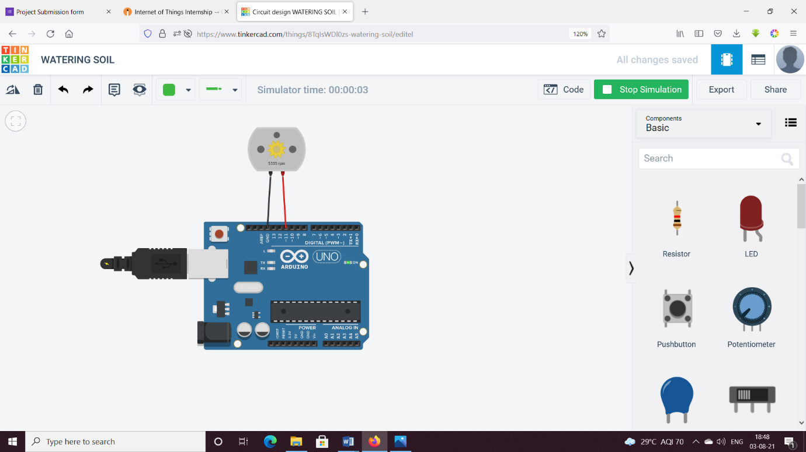

Step 2 – Code

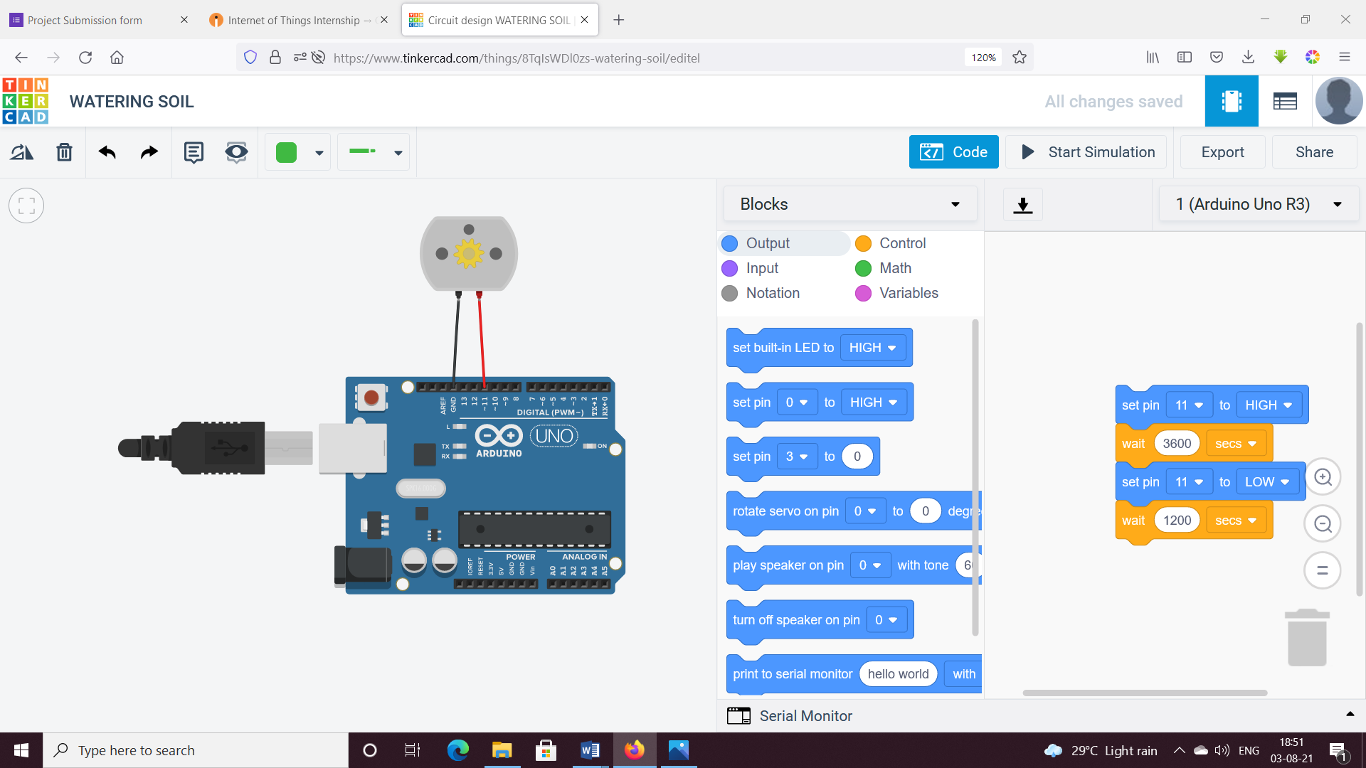

Text Code:

// C++ code

//

void setup()

{

pinMode(11, OUTPUT);

}

void loop()

{

digitalWrite(11, HIGH);

delay(3600000); // Wait for 3600000 millisecond(s)

digitalWrite(11, LOW);

delay(1200000); // Wait for 1200000 millisecond(s)

}